Project Design Phase
Frontend Design and Integration (Supplementary)
Date | 28 October 2026
Team ID | To Be Confirmed
Project Name | HotelPro – Hotel Management System
Maximum Marks | Supplementary
Document Status | Draft v1.0 – prepared from the stated HotelPro requirements. No HotelPro source code has been provided or verified, so all features are marked Planned.

1. Introduction
This document describes the planned UI architecture of the HotelPro React client: navigation, pages by role, reusable components, API integration, responsive design, search filters, pagination, error handling and charts. All pages are Planned; routes and component names are proposals to be reconciled with the source code (To Be Confirmed).

2. UI Architecture
Table 1: UI architecture
Concern | Planned Approach
Framework and routing | React.js single-page application with React Router; public routes and role-protected routes
UI library | Bootstrap grid/utilities and Material UI components (forms, tables, dialogs) where applicable
API integration | Axios instance with base URL from environment variable; request interceptor adds JWT; response interceptor handles 401 (logout/redirect) and normalises errors
State management | React Context for auth and notifications; local component state elsewhere (a state library is not assumed – TBC)
Feedback | React Toastify for success/error toasts; inline field-level validation messages
Charts | Chart.js (react-chartjs-2) or Recharts for occupancy, revenue and booking trends
Folder layout (proposed) | pages/, components/, layouts/, context/, services/ (API modules), routes/ (guards), utils/

3. Navigation Structure
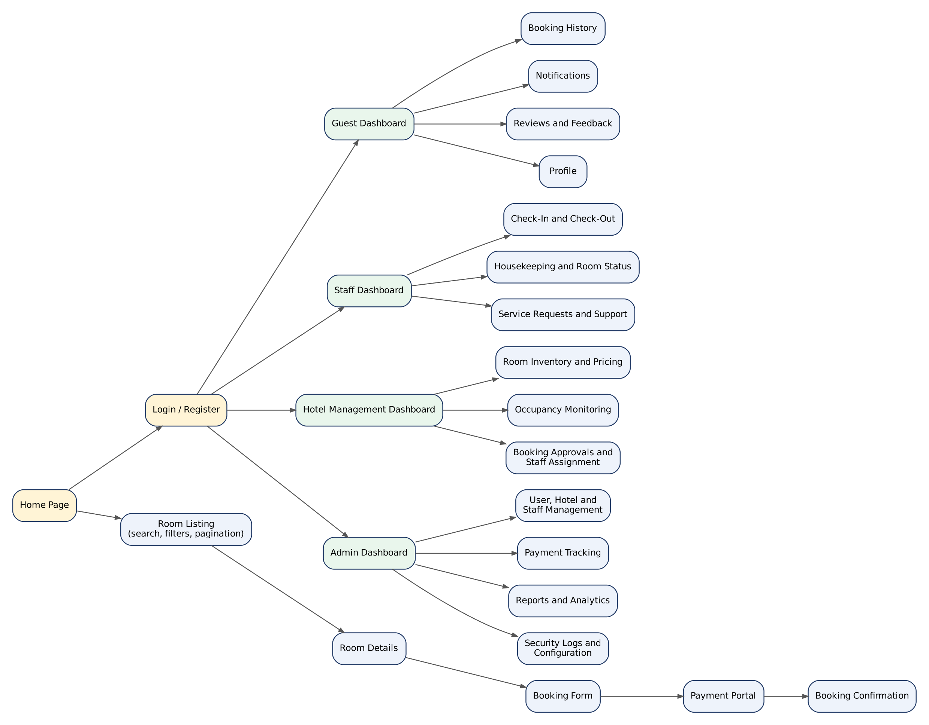
Figure 1: Planned page and navigation structure by role

4. Page Inventory
Table 2: Page inventory
Page | Route (proposed) | Role | Main Content / Behaviour | Requirement | Status
Home Page | / | Public | Hero search (dates, guests), featured rooms, hotel info | FR-G4 | Planned
Login / Register | /login, /register | Public | Forms with validation; email-verification message | FR-G1, FR-G2 | Planned
Room Listing | /rooms | Public | Search filters (dates, guests, type, price, amenities), sort, pagination, room cards | FR-G4 | Planned
Room Details | /rooms/:id | Public | Gallery, amenities, price, availability check, reviews, Book button | FR-G4 | Planned
Booking Form | /booking/:roomId | Guest | Dates, guests, special requests, price breakdown, policy summary | FR-G5 | Planned
Payment Portal | /payment/:bookingId | Guest | Gateway checkout, status polling, success/failure result | FR-G6 | Planned
Guest Dashboard | /dashboard | Guest | Upcoming stay, quick links, notifications preview | FR-G7, FR-G10 | Planned
Booking History | /bookings | Guest | Filterable list, details, cancel, modification and refund requests | FR-G7, FR-G8 | Planned
Notifications | /notifications | Authenticated | List, unread badge, mark read | FR-G10 | Planned
Reviews and Feedback | /reviews | Guest | Write review for completed stays; view own reviews | FR-G9 | Planned
Profile | /profile | Authenticated | Edit profile, change password | FR-G3 | Planned
Staff Dashboard | /staff | Staff | Today’s arrivals/departures, tasks, requests | FR-S1–S5 | Planned
Check-In and Check-Out | /staff/stays | Staff | Search booking, verify ID, check in/out, final bill | FR-S1 | Planned
Room Status / Housekeeping | /staff/rooms | Staff | Status board, task list | FR-S2, FR-S4 | Planned
Service Requests and Support | /staff/requests | Staff | Request queue and ticket replies | FR-S5, FR-S6 | Planned
Hotel Management Dashboard | /manager | Manager | Occupancy KPIs, approvals, staff assignment | FR-M3–M6 | Planned
Inventory and Pricing | /manager/inventory | Manager | Rooms, categories, seasonal rules | FR-M1, FR-M2 | Planned
Admin Dashboard | /admin | Admin | System KPIs, recent activity | FR-A1–A6 | Planned
User, Hotel and Staff Management | /admin/users | Admin | Tables with search, filters, status toggle | FR-A1 | Planned
Payments and Bookings Monitor | /admin/payments | Admin | Filtered lists with totals | FR-A2, FR-A3 | Planned
Reports and Analytics | /admin/reports | Admin / Manager | Date-range filters, charts, export | FR-A4 | Planned
Security Logs and Settings | /admin/security | Admin | Log viewer, platform settings | FR-A5, FR-A6 | Planned

5. UI Behaviour Guidelines
Table 3: UI behaviour guidelines
Topic | Planned Design
Responsive design | Mobile-first layout; breakpoints at 576, 768, 992 and 1200 px; tables become cards or scroll horizontally on small screens; verified at 360, 768 and 1280 px
Search filters | Check-in/out dates (date validation), guests, room type, price range slider, amenities; filters stored in URL query so results can be shared and bookmarked
Pagination | Server-side pagination with page size selector; loading skeleton and empty states
Forms | Client-side validation matching server rules; disabled submit while loading; clear error messages
Error handling | Toast for transient errors; inline messages for validation; 401 → login redirect; 403 → “Not authorised” page; 404 page; error boundary for rendering failures; retry for failed loads
Charts | Occupancy rate (line), revenue by month (bar), bookings by status (doughnut), room-status distribution; accessible titles and data table fallback
Accessibility | Semantic elements, labels, keyboard focus, alt text for images, contrast checks
Security in UI | Route guards by role; hide actions the role cannot perform (server still enforces)

6. Frontend Integration Points
Table 4: Integration map
UI Area | Service Module (proposed) | Backend Group
Authentication, profile | authService | /api/auth, /api/guests
Rooms and search | roomService | /api/rooms, /api/room-categories
Bookings | bookingService | /api/bookings
Payments | paymentService | /api/payments (gateway SDK/checkout on client)
Operations | stayService, housekeepingService, requestService | /api/stays, /api/housekeeping, /api/service-requests
Reports | reportService | /api/admin/reports, /api/manager/occupancy
Admin | adminService | /api/admin, /api/staff, /api/hotels

References
- React Documentation – https://react.dev/
- React Router – https://reactrouter.com/
- Axios Interceptors – https://axios-http.com/docs/interceptors
- Material UI – https://mui.com/material-ui/
- Bootstrap – https://getbootstrap.com/docs/
- React Toastify – https://fkhadra.github.io/react-toastify/introduction/
- Chart.js – https://www.chartjs.org/docs/
- WCAG 2.1 Quick Reference – https://www.w3.org/WAI/WCAG21/quickref/

